Westbere Parish Council – Special Edition Newsletter

Responding to the Local Plan: A shortish guide

Introduction
The Local Plan (LP) is part of a fundamental series of policy documents which cover housing developments, economic growth, transport, and the environment of Canterbury District. A Local Plan is a legal requirement in law, and without it a Council loses much of the control it should have over planning decisions. The LP sets out a series of specific and technical policies which Councillors must refer to when making decisions on planning applications. It is therefore critical that the LP is clear, legally enforceable, and reflects the views of residents.

The current consultation
Canterbury City Council is currently consulting on a new LP to run from 2025 to 2040. There are related consultations on Transport (including a new Bus Strategy), Air Quality, and Open Spaces.

You can find links to all the relevant documents here: https://news.canterbury.gov.uk/latest-consultations/

The Council is holding three public information sessions across the district where you can talk to council officers about the draft Local Plan in person: For Canterbury area this is on Monday 29 April, 6pm to 8pm: The Guildhall, St Peter’s Place, Canterbury, CT1 2DB
You do not need to register to attend.
The consultations on all policies close at 5 p.m. on Monday 3rd June 2024. All residents and organisations across the district can respond to the consultation.

How to respond

Residents can only make one response to the LP.

There is an online response form. This sets out every single policy in the order they appear in the LP document. Since many of them will not be of interest to most of you, as Westbere residents, this makes it quite long-winded to complete. You can only respond once, so if you were to accidentally “Submit” instead of “Save” before you have finished, you will lose the ability to make additional comments.

Westbere Parish Council recommend therefore that residents respond by email. You can submit general comments, or you can follow the structure of the online form but only referring to those aspects which are relevant to you. A copy of the questionnaire is downloadable here:
https://news.canterbury.gov.uk/wp-content/uploads/2024-Local-Plan-2040-paper-version.pdf
Email your comments to: consultations@canterbury.gov.uk

Whichever method you choose to use – including the Council’s online questionnaire – we recommend that you pre-prepare your responses in a document before submitting them.

Finally, we suggest that it is as important to comment positively on any policies that you support, as it is to critique or propose amendments to those policies which are of concern to you.

Structure of the LP
One slightly confusing aspect of the draft LP is that policies which apply across the district and apply to all prospective developments are set out in sections 6, 7 and 8 - after the sections relating to specific sites earmarked for development. In the site-specific policies these general policies tend to be referred to, making this confusing. Even more reason we recommend you read and prepare any comments on those latter sections before you comment on any specific site.

The early sections of the LP set out what the Council describes as a “Spatial Strategy for the District” followed by area specific sites selected for development. Each of these sections sets out planning policies and contains relevant maps and layout plans. The maps are often less than ideal but is adequate for most respondents to use. If you like detailed online maps you may find it helpful to look at the Council’s online “interactive” map:

https://experience.arcgis.com/experience/1e8c61757821421e8dc7d1eab938ed98/?draft=true

This is a quite complex map with multiple layers which you can switch on or off.

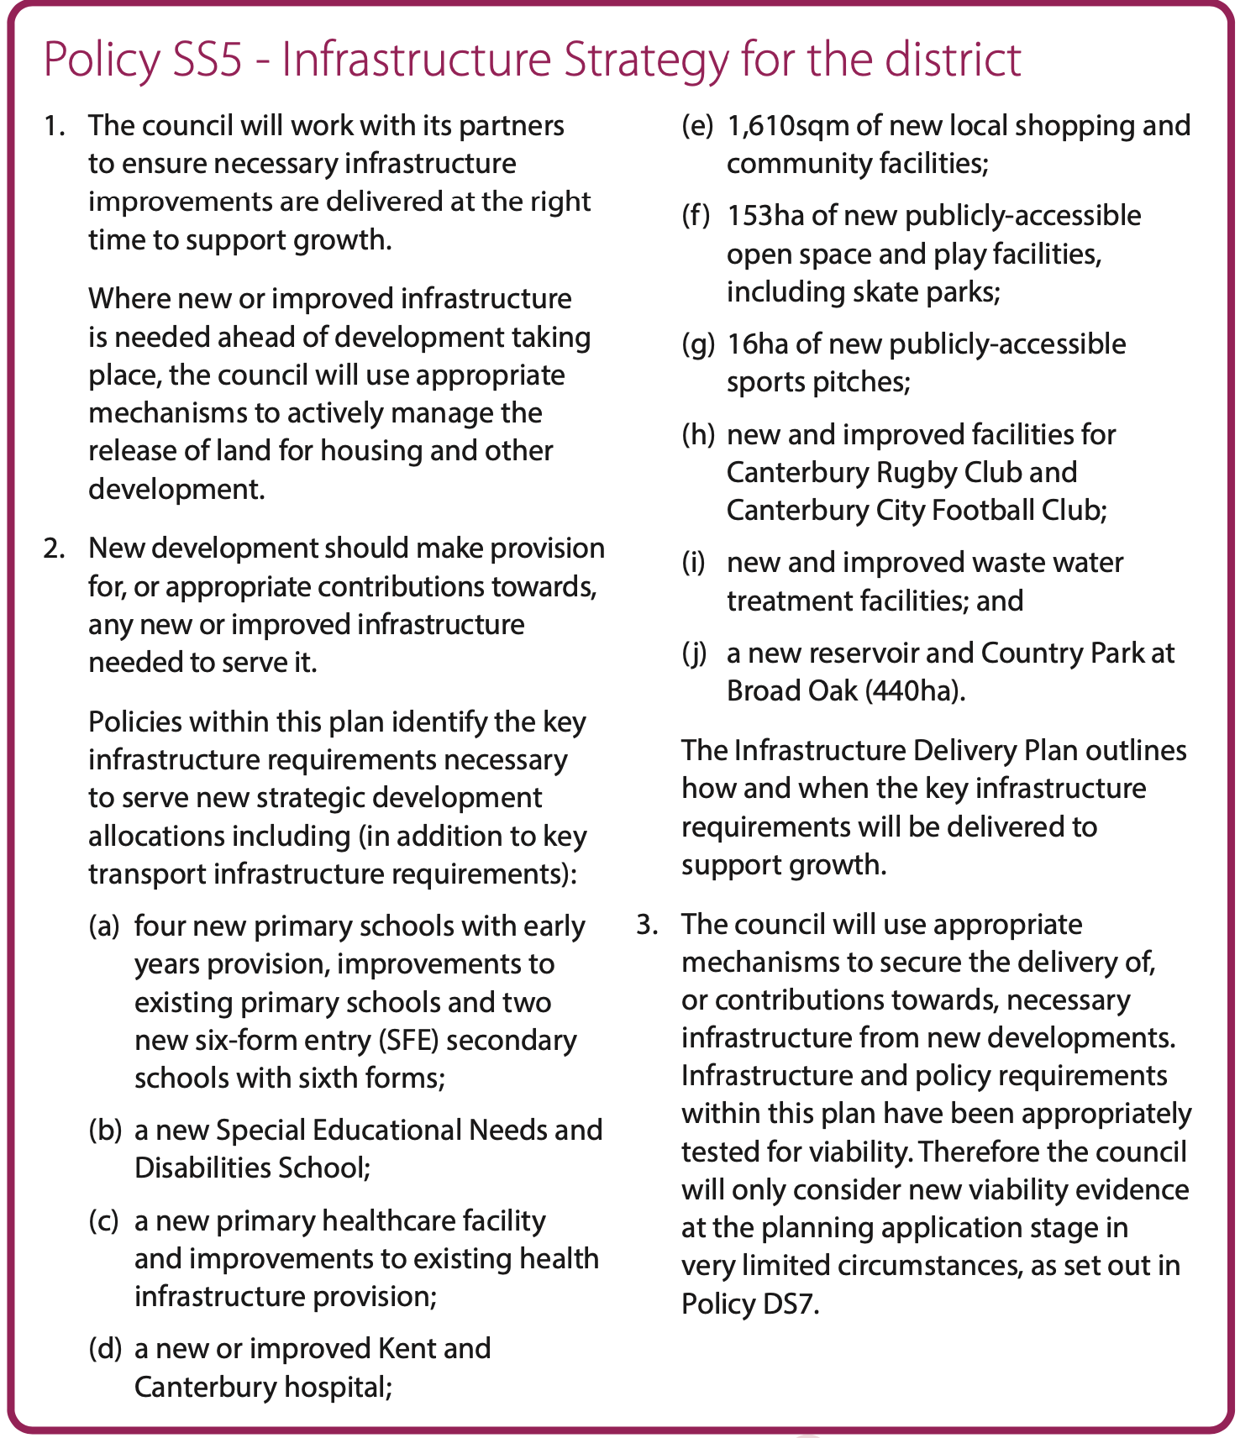
Every Policy has a reference code, and it is these you should refer to when responding to the LP. Note that although there is considerable explanatory text, only the text boxes as shown below contain the actual Planning Policy statements that will be referred to when making planning decisions.

Key policy sections for you to consider.
We did not seek to try to direct or prompt your priorities or opinions. But because the document is so long and complicated, we thought it is worth highlighting specific sections which have relevance to this Parish of Westbere and the surrounding areas:

- SS1 – Environmental strategy (page 12)
- SS2 – Sustainable design strategy (p13)
- SS3 – Development Strategy (p17)
- SS4 – Movement and transportation Strategy (p20)
- SS5 – Infrastructure Strategy (p22)
- C18 – Land east of Shelford Landfill (employment site with impact on Broad Oak Road) (p67)
- C20 – Land South of Sturry Road (earmarked as a strategic wetland for nutrient mitigation) (p71)
- R1 – Rural Service centres – including Sturry (p111)
- R5 – Bread and Cheese Field (p119)
- R6 – Hersden (p121)
- R9 – Popes Lane (p130)
- R10 – The Paddocks, Shalloak Road (p132)
- R14 & R15 – Goose Farm, Shalloak Road (pp140-142)
- R17 – Broad Oak Reservoir (p146)
- CF1 Land at Broad oak and north of Hersden (p232)
- CF8 – Sturry Relief Road (p242)
- The Transport strategy p14 – refers to extensions of the Sturry railway station platform extension - the lengthening of the Sturry platforms would negate overhang and reduce barrier down time – Westbere Parish Council has held a long desire for this and would encourage residents to support this.
- The Natural Environment and Open Space Topic Paper (2022) - pages 67-69 refer to the “green gap” allocation at Headleys Field. The best map for this is contained within this document p66: https://drive.google.com/file/d/14_b45IxUuUrBXBFBOoHb3m_x4rhVQadk/view

